Date returned …………………………..


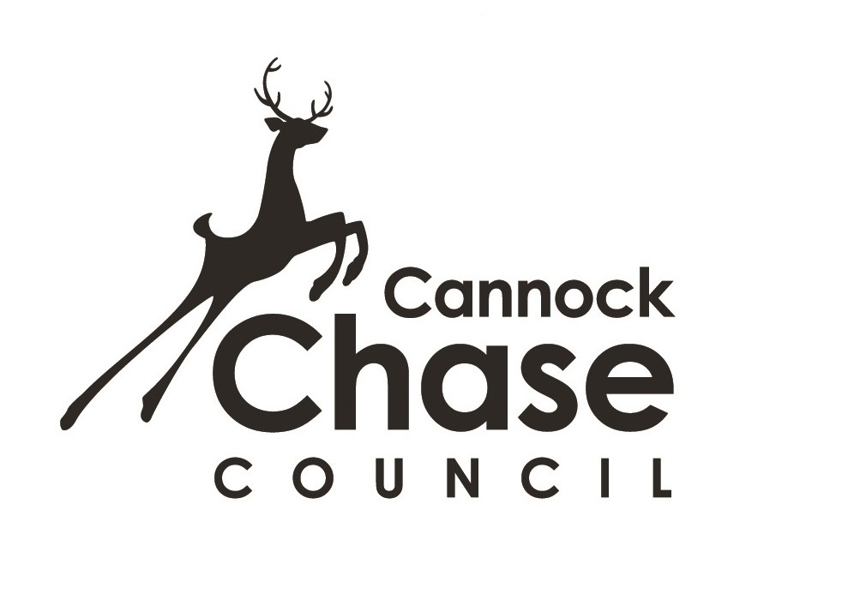
Temporary Exhibitions Policy – Museum of Cannock Chase

Statement of Purpose
The Museum of Cannock Chase has two temporary exhibition spaces. The temporary exhibition gallery is a large room (5.20mx 7.20m), whilst the Coffee Shop has a small display area on two of its walls. The Exhibition Gallery is used for professional artists or high quality amateurs, travelling exhibitions and in house exhibitions, whilst the Coffee Shop is aimed at enthusiastic amateurs, hobby artists or those just starting out on a career in the art world.

Whilst exhibitors will be invited to display work in the temporary exhibition space by the Museum staff, the Coffee Shop space is available to hire by artists to display their work, subject to selection by the Museum staff and sometimes other Inspiring Healthy Lifestyle units.

The purpose of the Temporary Exhibitions Policy is:

- To provide clear guidance on the use of the temporary exhibition space, for the museum staff, arts development officers and potential exhibitors.
- To clearly state our vision for the temporary exhibition space at the museum, how we will use and administer the space, working with other Inspiring Healthy Lifestyle units and what we hope to achieve through the staging of temporary exhibitions.

Vision
The Museum of Cannock Chase, working with other Inspiring Healthy Lifestyle units, aims to provide a varied and innovative programme of high quality temporary exhibitions by local professional and amateur artists, and by national and international artists, art galleries and museums, that will inspire, encourage and entertain our visitors and support the appreciation and development of visual arts in our district.

Objectives

- To create an arts venue that people aspire to be involved with and engage with, both locally and outside the district.
- To provide a varied and changing selection of quality exhibitions to appeal to a variety of audiences and tastes.
- To provide a quality experience for visitors to the museum.
- To compliment and support the museum’s permanent displays and mission statement, as well as events and projects organised by the museum and other Inspiring Healthy Lifestyle units.
- To increase the opportunity for local professional artists to exhibit in the district.
- To inspire and raise the aspirations of artists in and around the Cannock Chase District.
- To increase the standard of exhibitions on show to reflect the increasing quality and status of the museum and other Inspiring Healthy Lifestyle units.
- To increase the number of users to the museum and to increase support of the work of the museum and other Inspiring Healthy Lifestyle units.
- To encourage return visits to the museum to see regularly changing temporary exhibitions.
- To provide special evenings related to temporary exhibitions, such as private views.
- To raise the profile of the museum and other Inspiring Healthy Lifestyle units.
- To display exhibitions that are relevant to the museum’s target audiences.

Procedures

Temporary Exhibition Gallery

- The temporary exhibition gallery exhibits high quality work from professional artists or groups, high quality amateur artists, travelling exhibitions from other museums and in house exhibitions.

- As well as artists approaching the museum to exhibit their work, the museum and other Inspiring Healthy Lifestyle units will actively seek artists to display their work in the gallery. The museum will also work with other Inspiring Healthy Lifestyle units to create or buy in temporary exhibitions to compliment the permanent exhibitions or other projects undertaken by the museum and/or other Inspiring Healthy Lifestyle units.

- A selection process will be employed by the museum and sometimes other Inspiring Healthy Lifestyle units team to choose exhibitions to be displayed in the temporary exhibition gallery. Artworks chosen for display will be at the discretion of the museum and sometimes other Inspiring Healthy units..

- Potential exhibitors must submit an exhibition proposal including a description of their work and ethos, why they wish to exhibit at the museum, a CV and examples of their work for consideration. Submission of a proposal is no guarantee of an exhibition slot being granted by the museum.

- Selection criteria includes: Quality of work, and how the exhibition/work compliments other exhibitions in the programme. Unusual and innovative works are encouraged, as well as good quality traditional media.

- Allocation of exhibition dates is at the discretion of the museum.

- A cancellation fee will apply if an exhibitor cancels an exhibition booking. Should the exhibitor wish to cancel, the museum will require in writing the reason for the cancellation.

- All works must be supplied to the museum ready to hang, in good quality frames with picture plates attached to ensure that they can be secured to the wall. Any pictures not meeting these conditions will not be included in the exhibition.

- Before confirming a booking, it is the responsibility of the artist(s) to ensure that artwork for exhibition can be accommodated on the display boards in the gallery space and to check that the museum has suitably sized display cases for any 3D works. We advise that artists submit a rough plan showing how they envisage their works being displayed. The museum reserves the right to change this plan if necessary.

- Exhibitions will be evaluated through artist and visitor feedback.

- All works sold during the exhibition will be subject to a commission fee.

Coffee Shop

- The Coffee Shop is available for hire by amateur and hobby artists at a weekly cost to display two dimensional artworks or photographs.

- Depending upon the size of the works, the maximum number of pictures that can be exhibited is between 15 and 20.

- Potential exhibitors must submit an exhibition proposal, including a description of their work and ethos, why they wish to exhibit at the museum, a CV and examples of their work for consideration. Submission of a proposal is no guarantee of an exhibition slot being granted by the museum.

- Exhibitions in the Coffee Shop will be selected by the museum staff.

- To secure the booking of the display space, a booking form must be completed and signed.

- A cancellation fee will apply if an exhibitor cancels an exhibition booking. Should the exhibitor wish to cancel, the museum will require in writing the reason for the cancellation.

- All works must be supplied to the museum ready to hang, in good quality frames with picture plates attached to ensure that they can be secured to the wall. Any pictures not meeting these conditions will not be included in the exhibition.

- Before confirming a booking, it is the responsibility of the artist(s) to ensure that artwork for exhibition can be accommodated on the display boards in the gallery space. We advise that artists submit a rough plan showing how they envisage their works being displayed. The museum reserves the right to change this plan if necessary.

- Allocation of exhibition dates is at the discretion of the museum.

- All works sold during the exhibition will be subject to a commission fee

The museum reserves the right to change any of the above procedures at any time.

Date returned ……………………………………

Museum of Cannock Chase
Temporary Exhibitions Proposal Form

A selection process is used to choose temporary exhibitions for display at the museum. Exhibition proposals are considered by the museum and other Inspiring Healthy Lifestyle units’ staff. In order to allow us to fully consider your proposal, please provide as much information as possible and include if possible an up to date CV and any images showing examples of your work. Use further sheets if necessary.

Name:
Address:
Home Telephone:

Mobile Telephone:

Email Address:

Title of your Exhibition:

Brief description of your exhibition, including the ethos behind it. Include information on the themes in your exhibition, art forms and techniques employed, etc.
(include details of the number and size of works. Is your work 2D or 3D*? Do you need display cases? Are there any interactive elements for visitors?)
* Please note that the coffee shop is not suitable for 3D works.

Please give brief details of any previous exhibitions you have had.

Why do you wish to exhibit at the Museum?

Who is your exhibition aimed at?

Will your exhibition provide any opportunities for visitors to learn something, or change their opinions?

What interpretation material (eg, written text, images or background information) could you provide to support your exhibition?

Are they any opportunities for workshops, activities or events to link with your exhibition?

Are their any health & safety issues for visitors or staff connected to your exhibition?

Are there any sensitive issues or images in your exhibition that might be considered controversial?

Any other information you would like us to consider?

Thank you. We will be in touch.
Data Protection: The Museum of Cannock Chase/Inspiring Healthy Lifestyles would like to retain your details for the purposes of informing you about what’s on at the museum with regard to current and forthcoming exhibitions. We would also like to inform you of exhibition space availability. We will not pass on your details to anyone outside Inspiring healthy lifestyles or outside any organisation managing the museum.
Please indicate here whether you are happy for us to hold and use your details in this way Yes/No
Please let us know how we can contact you - via Post Yes/No Email Yes/No Telephone Yes/No
You may opt out at any time by contacting the museum – museumofcannockchase@ihlmail.org or by writing to us at Museum of Cannock Chase, Valley Road, Hednesford, WS12 1TD.
For more information about the Inspiring Healthy Lifestyles privacy policy, please visit www.inspiringhealthylifestyles.org/privacy

